ALTERNATIVE SAFETY
Many abolitionists agree that the goal is not just to replace police and prisons with more humane alternatives, but to create a holistic approach to community safety that meets people’s needs.
Vision: A police-free, prison-free world that confronts the impacts of white supremacy, capitalism, and hetero-patriarchal violence. Community members resolve their own problems, address harm when it occurs, and have access to the things they need to be truly safe, such as affordable housing, youth programs, mental health services, addiction treatment options, jobs programs, education, etc.

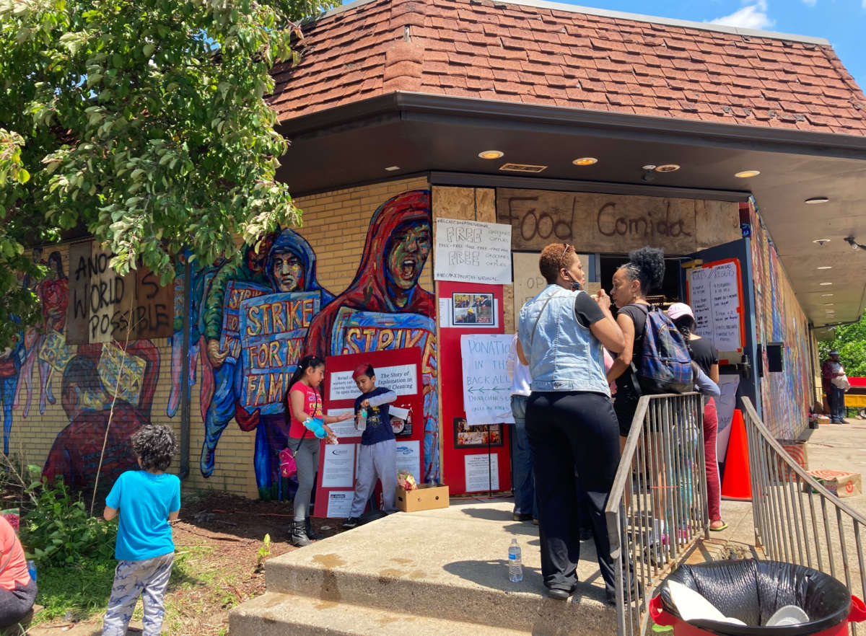

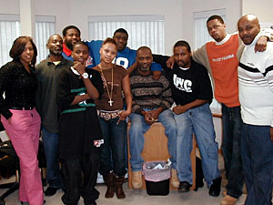
Minneapolis organizers’ long-term work building a vision of comprehensive community safety laid the groundwork for the City Council vote to abolish the police department.
- Group Violence Intervention Project de-escalates tension between gangs in Minneapolis without involving police.
- Sexual Violence Center supports survivors of sexual violence, and trains volunteer advocates.
- MN activists have called for comprehensive sex education in schools that includes curricula on consent, bodily autonomy, and healthy relationships as a way to prevent gender-based violence.

MAD DADS engages, trains, and promotes positive images of parents intervening in and preventing community problems.
- During the uprisings for Black lives in Minneapolis, organizers turned a hotel into a sanctuary for unhoused people, providing protection from police and right-wing militants, food, and shelter.

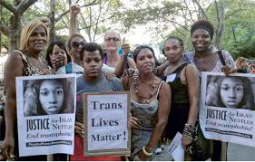

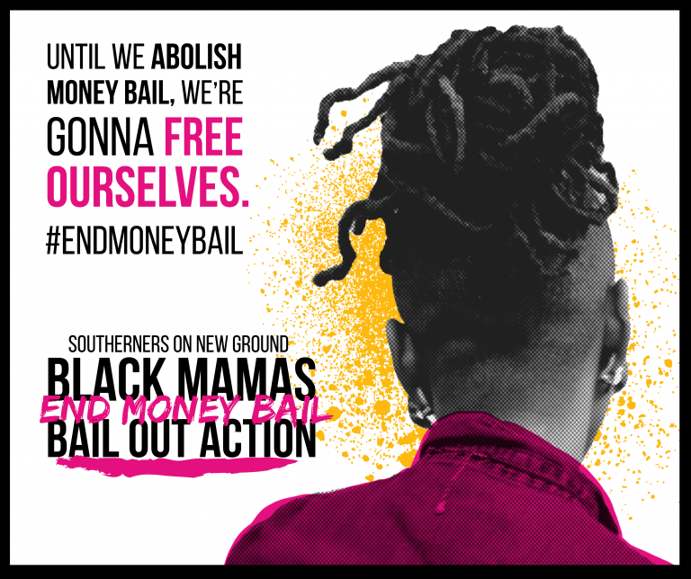
New York City
Common Justice operates alternative-to-incarceration and victim-service programs that focus on solutions to transform the lives of those harmed and foster racial equity.
The Audre Lorde Project’s Safe OUTside the System Collective challenges hate and police violence affecting LGBTSTGNC people of color by building stronger community & ally relationships to prevent, intervene, and challenge violence.

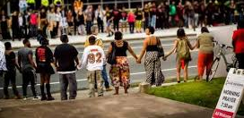
Durham Beyond Policing: Durham organizers have created a holistic alternative vision of safety.
- SpiritHouse Inc’s Harm Free Zone seeks to repair the damage of racism and oppression of poor people of color through empowering community members to capacity to prevent, confront and transform harm.
- BYP100’s She Safe, We Safe is a transformative movement campaign to put an end to the different forms of gender violence that Black women, girls, femmes and gender non-conforming people face everyday.
- The Good Lookin’ Out Neighborhood Project challenges the criminalization of Black & Brown people by providing communities with resources to assess conflict, de-escalate, and use TJ/RJ methods instead of calling police.
- Sanctuary Beyond Walls: The CityWell Church congregation and other community members have fought family separation and protected people from deportation by ICE.
- The Black Mama Bail Out Action builds on Black liberation history of enslaved people buying each other’s freedom. Southerners on New Ground organizes the bail out of Black mothers for Mothers Day and connects them with community resources.

what alternative models would keep everyone in YOUR COMMUNITY safe?

FURTHER STUDY
Minneapolis:
Black Visions Collective & Reclaim the Block’s description of building power projects to replace Minneapolis PD (and PD in other cities): https://static1.squarespace.com/static/5d8faf6f8ba16e7343478cdb/t/5edfb4912cdf0d320a51c28d/1591719059704/MPLS+One+Pager+FINAL.pdf
Group Violence Intervention Project in Minneapolis: https://www.minnpost.com/metro/2019/11/after-positive-results-minneapolis-looks-to-expand-anti-violence-program/
Uprisings Are Driving a Surge in Mutual Aid in Minneapolis and Beyond: https://truthout.org/articles/uprisings-are-driving-a-surge-in-mutual-aid-in-minneapolis-and-beyond/
More details on hotel housing sanctuary: https://themacweekly.com/78151/home/organizers-turn-midtown-sheraton-into-housing-sanctuary/
MPD150 has all kinds of amazing resources, including printable flyers & examples of alternatives. Here is an audio version of their powerful 150 year review of the Minneapolis Police Department (also available in PDF & online): https://www.mpd150.com/report/audio-report/ (1.5 hours)
Durham, NC:
This incredible report on the police abolition fight by the Durham community. Building power alternatives in Durham are described starting on page 25. Projects in additional cities are described starting on page 36: https://durhambeyondpolicing.org/wp-content/uploads/2019/07/Durham-Beyond-Policing-Budget-Proposal-2019-2020.pdf
https://www.spirithouse-nc.org/harm-free-zone/
Recent article on Durham uprisings (June 17): https://indyweek.com/news/durham/durham-activists-push-to-defund-the-police/
New York City:
Short radio story on Common Justice: https://www.wnyc.org/story/common-justice-crime-victims-and-their-perpetrators/ (7 minute)

Beautiful video on Audre Lorde Project’s Safe Outside the System program: https://youtu.be/tTUxQhorwXY (7 minutes)
Abolition:
Interview with Mariame Kaba: https://www.nbcnews.com/think/opinion/thinking-about-how-abolish-prisons-mariame-kaba-podcast-transcript-ncna992721
Extensive collection of Alternative Safety resources, created from Mariame Kaba: https://transformharm.org/

