HEALTHCARE & RESISTANCE

From 1969 – 1972, **The Young Lords**, Puerto Rican revolutionaries in New York City, took a number of direct actions to get accessible and free healthcare for their community. This work was part of their overall anticapitalist vision of liberation for all oppressed people.

**The Young Lords** waged a sit-in to get lead testing kits, and got training from radical doctors in how to use them. They seized an x-ray truck that the city used for tuberculosis tests to bring free testing to their community.

And **The Young Lords** collaborated with radical health care workers to fight budget cuts at the local hospital. "On July 14, 1970, 150-200 militants led by The Young Lords...occupied The Nurses Residence of Lincoln Hospital. Once inside, The Young Lords set up screening clinics for anemia, lead poisoning and tuberculosis, as well as a day care center and a classroom for political and health education."

**Action Medics** have been on the front lines with protesters, from the Arab Spring to Occupy to Black Lives Matter protests from Ferguson to today.

The struggle for healthcare access is connected to **Abolition**. Organizations like Critical Resistance and Movement for Black Lives are demanding healthcare without police, and ways to access care without calling 911. Activists are demanding healthcare for all, paid for by defunding police.

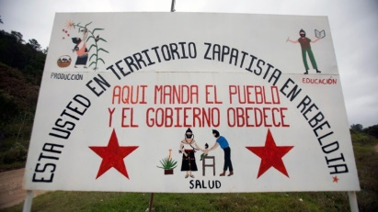

**How can the lessons from past healthcare crises and grassroots responses help us today?**

More Alternatives to Check Out…

**Harriet’s Apothecary**

Founded in 2014, Harriet’s Apothecary is a mobile, intergenerational, healing village led by the brilliance and wisdom of Black Cis Women, Queer and Trans healers, artists, health professionals, magicians, activists and ancestors, and committed to co-creating accessible, affordable, liberatory, all-body loving, all-gender honoring, community healing spaces that recognize, inspire, and deepen the healing genius of people who identify as Black, Indigenous and People of color and the allies that love us. Their work is a deliberate response to a violent and racist society and systemic racism in healthcare.

**ACT-UP (The AIDS Coalition to Unleash Power)**

Starting in 1987, ACT-UP fought against homophobia, transphobia, racism, sexism, drug company profiteering, religious intolerance, media silence, and corrupt politics. The organization was led by those most affected, and members did not hesitate to put their bodies on the line. ACT-UP members also did medical research and cared for loved ones.

Brazil.

Chiapas, Mexico.