ALTERNATIVE ECONOMIES

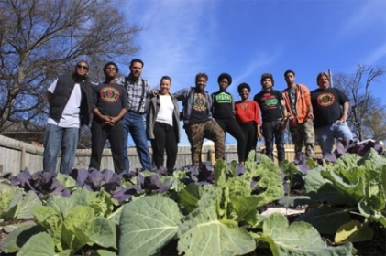

**Cooperation Jackson** works to place the ownership of land and control of production into the hands of the Black working class of Jackson, Mississippi.

*Vision:* Develop an **ecologically regenerative**, democratic economy rooted in the **self-determination for people of African descent** and **radical decolonization** of Mississippi.

*Structure:* Creation of a **Solidarity Economy** anchored in a federation of interconnected and interdependent worker owned cooperatives to meet the needs of the people and through the building a Community Land Trust to steward and develop land for common good.

*Projects*: * Freedom Farms, Center for Community Production, Green Team, Community Arts Festival *Transformation of a mall into Ida B. Wells Plaza to serve as an accessible space for cooperatives and hub for food sovereignty, time banking, and mutual aid initiatives

Learn More: Book by **Kali Akuno, “Jackson Rising”**

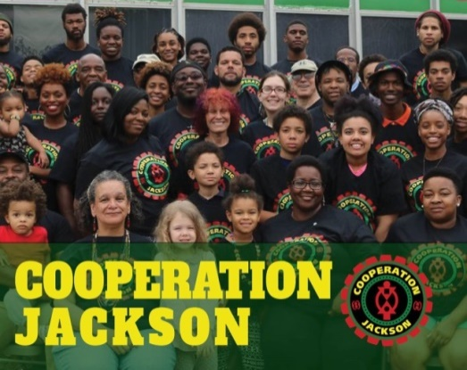

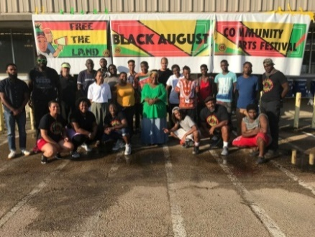

**WHAT ALTERNATIVE ECONoMY DO YOU IMAGINE IN YOUR COMMUNITY?**

More Alternative Economies to Check Out…

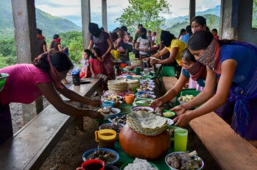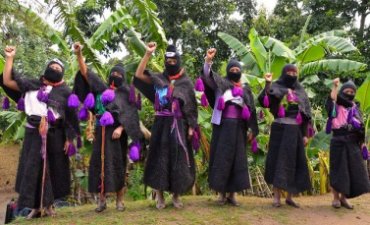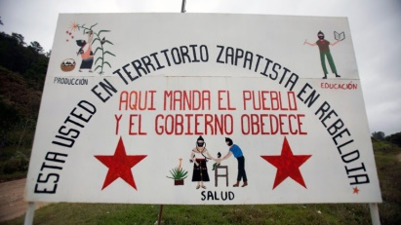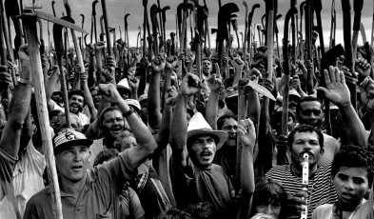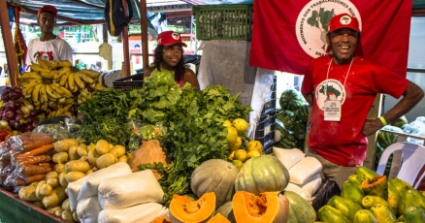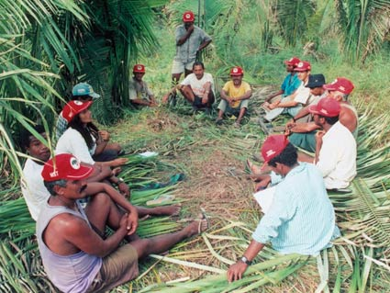

**Zapatista Autonomous Territories, Mexico.**

Over 350,000 Indigenous people self-govern through ‘Good Government Councils’ and an economy based on common ownership and cooperatives that self-sustain since the uprising in 1994.

“**The Uprising of Dignity” (YouTube)**

**Landless Workers Movement, Brazil (MST).**

Rural workers have carried out 2,500 occupations of privately held land all over Brazil, creating ‘Land Reform Communities’ that practice agro-ecology and direct democracy for the whole community.

“**Brazil: Landless Workers Movement” (Youtube)**

Brazil.

Chiapas, Mexico.